Table of Contents
Changing Column Names 1
Sorting a DataFrame 3
Filtering a DataFrame 4
Numeric DataFrame Summaries 5
DataFrame (Groupby) 6
Grouping on Columns 6
Generating a Calculated Column 9
Grouping on Multiple Columns 10
Modifying one Cell of a Data Frame at a Time 10
Converting Strings to Numbers 12

Submission Instructions:
10% will be deducted each day this document is late. Please do not submit pdf documents and do not zip your documents.

Note:
You are encouraged to work with others, and you can discuss your solutions verbally as well but DO NOT SHARE COPIES of YOUR WORK ELECTONICALLY OR IN ANY OTHER FORM. Keep good karma with your career network and protect your reputation – do not plagiarize.

Changing Column Names
For either development or reporting purposes you will often want to rename columns. This example shows how to convert the original column names to a more reader-friendly set.

Example 1: Changing Column Names

This example demonstrates how to rename the columns of the baby sample.
import pandas as pd

# Import data into a DataFrame.
path = "/Python/DataSets/babysamp-98.txt"
df = pd.read_csv(path, skiprows=1,
sep='\t',
names=('MomAge', 'DadAge', 'MomEduc', 'MomMarital', 'numlive',
"dobmm", 'gestation', 'sex', 'weight', 'prenatalstart',
'orig.id', 'preemie'))

# Rename the columns so they are more reader-friendly.
df = df.rename({'MomAge': 'Mom Age', 'DadAge':'Dad Age',
'MomEduc':'Mom Edu', 'weight':'Weight'}, axis=1) # new method
# Show all columns.
pd.set_option('display.max_columns', None)

# Increase number of columns that display on one line.
pd.set_option('display.width', 1000)
print(df.head())

Exercise 1 (3 marks)
import pandas as pd
path = "/Python/DataSets /bodyfat.txt"
df = pd.read_csv(path, skiprows=1,
sep='\t',
names=('Density', 'Pct.BF', 'Age', 'Weight', 'Height',
'Neck', 'Chest', 'Abdomen', 'Waist', 'Hip', 'Thigh',
'Ankle', 'Knee', 'Bicep', 'Forearm', 'Wrist'))
# Show all columns.
pd.set_option('display.max_columns', None)

# Increase number of columns that display on one line.
pd.set_option('display.width', 1000)

Starting with code above, rename the columns to be Height, Waist, Weight and “Percent Body Fat”. Show your revised program here: Note: if you can not find bodyfat.txt, you need to download it from your learning hub.
df2 = df[['Height','Waist','Weight','Pct BF']] #Creating a dataframe base in columns of other dataframe
df2 = df2.rename({'Pct BF':'Percent Body Fat'},axis=1)
print(df2)

Show a screenshot of your DataFrame output after printing it out here:
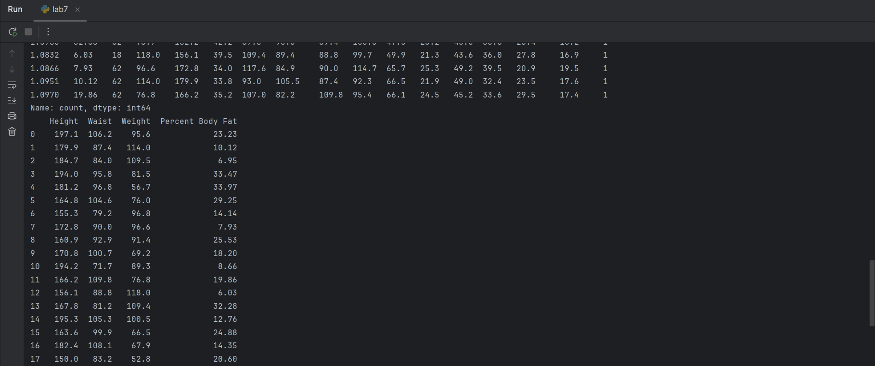

Analyzing Frequencies

With the value_counts() function you can get a quick understanding of the column ranges and frequency for each value.

Example 2: Frequencies and Ranges

Add these print statements at of the program in Example 1 to observe the range of values in the Mother’s age column. This code presents frequencies with different sorting options.
print("\nTOP FREQUENCY FIRST")
print(df['Mom Age'].value_counts())

print("\nLOWEST FREQUENCY FIRST")
print(df['Mom Age'].value_counts(ascending=True))

print("\nFREQUENCY SORTED by MOTHER AGE")
print(df['Mom Age'].value_counts().sort_index())

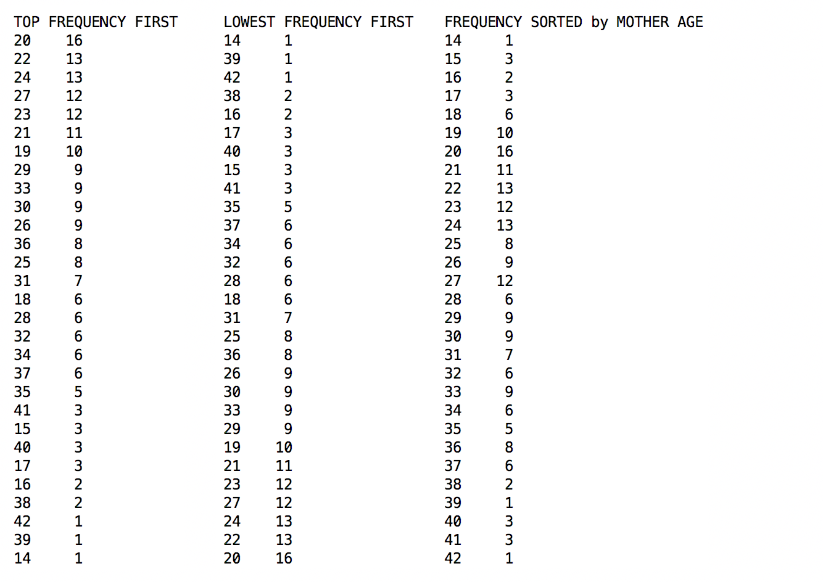

Exercise 2 (1 marks)
Show the code needed to produce a frequency count of unique values for Mother education sorted by education level.
print(df['Mom Edu'].value_counts().sort_index())
Show a screenshot of the frequencies when sorting by unique mother education levels.
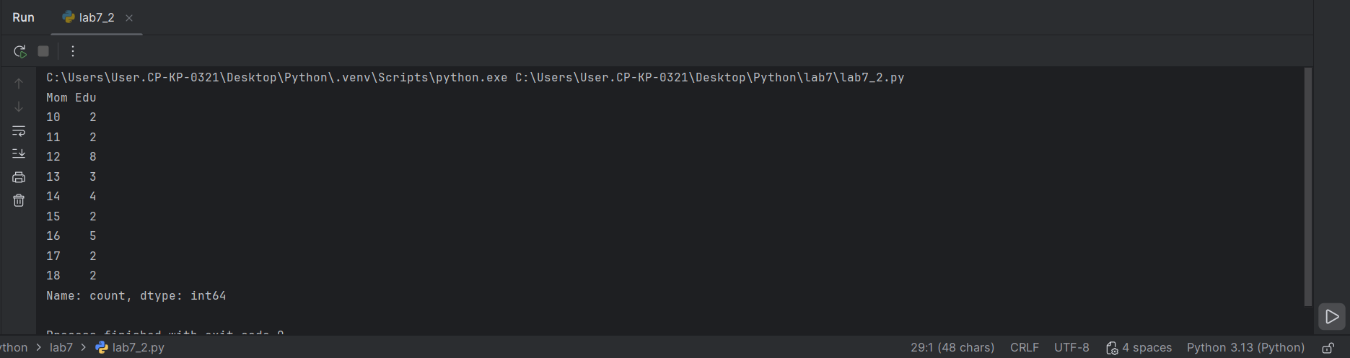

Sorting a DataFrame

The sort_values() method allows us to sort DataFrame rows by multiple column values in either ascending or descending order:

dfSorted = df.sort_values(['Mom Age', 'Weight'], ascending=[False, True])
print(dfSorted)

Sample output from running an instruction like the one above shows row output sequenced as specified:
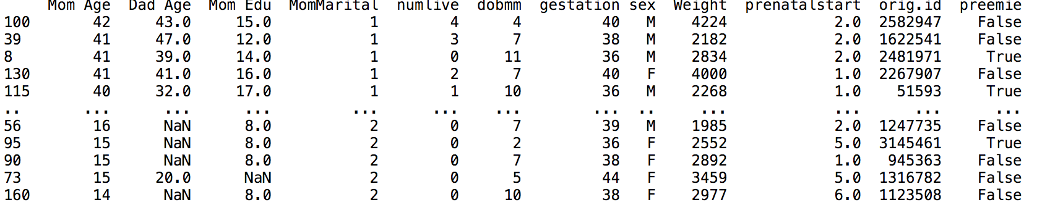

Example 3: Sorting DataFrame Content
This sample code implements all of the instructions needed to generate and display the ordered DataFrame content as shown above.
import pandas as pd

# Import data into a DataFrame.
path = "/Python/DataSets /babysamp-98.txt"
df = pd.read_csv(path, skiprows=1,
sep='\t',
names=('MomAge', 'DadAge', 'MomEduc', 'MomMarital', 'numlive',
"dobmm", 'gestation', 'sex', 'weight', 'prenatalstart',
'orig.id', 'preemie'))

# Rename the columns so they are more reader-friendly.
df = df.rename({'MomAge': 'Mom Age', 'DadAge':'Dad Age',
'MomEduc':'Mom Edu', 'weight':'Weight'}, axis=1) # new method
# Show all columns.
pd.set_option('display.max_columns', None)

# Increase number of columns that display on one line.
pd.set_option('display.width', 1000)

# Sort by descending mother age and then by ascending weight.
dfSorted = df.sort_values(['Mom Age', 'Weight'], ascending=[False, True])
print(dfSorted)

Exercise 3 (2 marks)
Starting with the code in Example 3, create a data frame which has rows which are sorted by gestation and then weight. Both gestation and weight are sorted in ascending order. Show your code here (no screenshot):
dfSorted2 = df.sort_values(['gestation','Weight'],ascending=[True,True])
print(dfSorted2)
Show a screenshot of the output here:
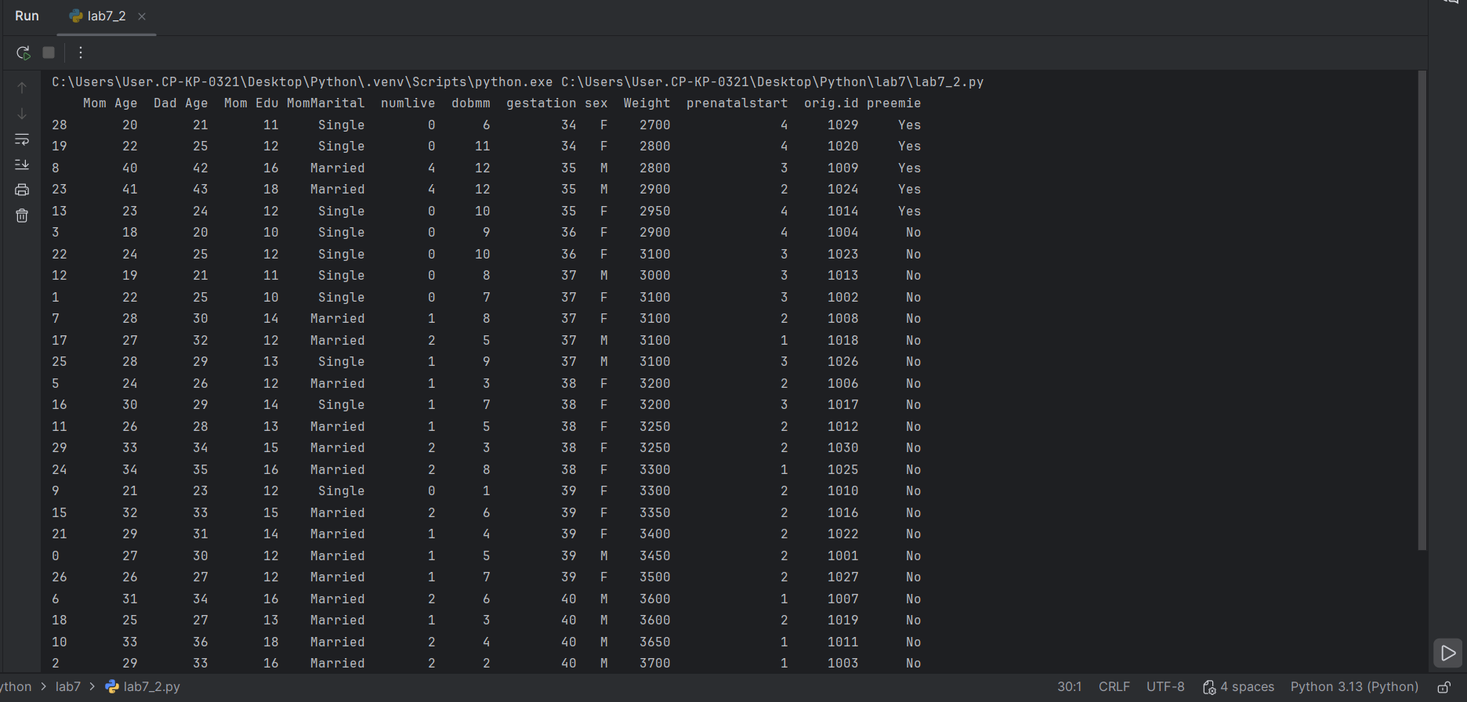

Filtering a DataFrame

It is possible to query a DataFrame with conditional expressions and compound conditions:

# Compound conditions require single '&' for 'AND'
# and single '|' for 'OR.
result = df[(df['DadAge']>40) & (df['MomAge'] > 30)]
result = df[(df['DadAge']>40) | (df['MomAge'] > 30)]

Example 4: Filtering with Compound Conditions
This example uses the baby-samp-98 sample to display infant birth statistics when both the mother and the father are 40 or older.
import pandas as pd

# Import data into a DataFrame.
path = "/Python/DataSets /babysamp-98.txt"
df = pd.read_csv(path, skiprows=1,
sep='\t',
names=('MomAge', 'DadAge', 'MomEduc', 'MomMarital', 'numlive',
"dobmm", 'gestation', 'sex', 'weight', 'prenatalstart',
'orig.id', 'preemie'))
# Show all columns.
pd.set_option('display.max_columns', None)

# Increase number of columns that display on one line.
pd.set_option('display.width', 1000)

# Compound conditions require single '&' for 'AND' and single '|' for 'OR.
resultDf = df[(df['DadAge']>=40) & (df['MomAge'] >= 40)]
print(resultDf)
The output from this program confirms the given age range:

Numeric DataFrame Summaries

When performing summaries often the DataFrames are summarized by category. For example, the original table shows the energy consumption per city. A provincial or state summary of total energy consumption would need to drop the city column and any other detail at the city level

Many functions exist to help individually summarize numeric DataFrame content. The methods chosen here for performing summaries are intended to keep the learning simple. However, more methods are documented at:
https://www.shanelynn.ie/summarising-aggregation-and-grouping-data-in-python-pandas/

Table 1: Numeric DataFrame Summary Functions
Function | Description
count() | Number of non-null observations
sum() | Sum of values
mean() | Mean of values
median () | Arithmetic median of values
min() | Minimum
max() | Maximum
std() | Unbiased standard deviation

Each of the summary functions in Table 1 can be applied to individual DataFrame columns:
# Show the average Mother's age.
print(df['MomAge'].mean())

Exercise 4 (3 marks)

Starting with the code from Example 4, use the column summary functions to produce the following summary of the mother’s age:

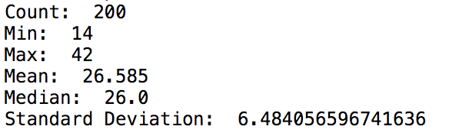
Show your program here (no screenshots please):
print(f'Count:{df['Mom Age'].count()}\nMin:{df['Mom Age'].min()}\nMax:{df['Mom Age'].mean()}\nMedian:{df['Mom Age'].median()}\nStandarDeviation:{df['Mom Age'].std()}')

DataFrame (Groupby)

Grouping on Columns
To group on columns, the groupby() function can be used. The syntax is a little awkward and there are several ways to implement it. I will present a way that I think is the least problematic in my opinion but you are welcome to experiment in case you want to implement grouping differently. A nice reference can be found here:
https://www.shanelynn.ie/summarising-aggregation-and-grouping-data-in-python-pandas/

Output as a Series

This first command shows the syntax needed to summarize call counts by phone network:
import pandas as pd
# The data file path and file name need to be configured.
PATH = "/Python/DataSets/"
CSV_DATA = "phone_data.csv"
# Note this has a comma separator.
df = pd.read_csv(PATH + CSV_DATA, skiprows=1, encoding="ISO-8859-1", sep=',',
names=('index', 'date', 'duration', 'item', 'month', 'network',
'network_type'))
dfStats=df.groupby('network')['index'].count()
print(dfStats)

The output when running such a command is presented in a ‘series’ format. The series is more reader-friendly since it does not include an indexes column on the left.

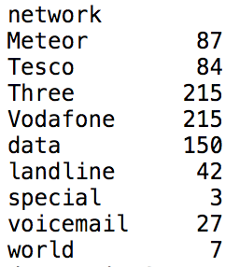

Output as a DataFrame

While the series output is often easier to read, we usually need a DataFrame to enable further manipulation of the data. The function, reset_index(), converts the series back to a DataFrame.
import pandas as pd

# The data file path and file name need to be configured.
PATH = "/Users/pm/Desktop/DayDocs/2019_2020/PythonForDataAnalytics/workingData/"
CSV_DATA = "phone_data.csv"

# Note this has a comma separator.
df = pd.read_csv(PATH + CSV_DATA, skiprows=1, encoding = "ISO-8859-1", sep=',',
names=('index', 'date', 'duration', 'item', 'month','network',
'network_type' ))
dfStats = df.groupby('network')['index']\
.count().reset_index().rename(columns={'index': '# Calls'})

The DataFrame output after using reset_index() includes an index column on the left. The output also includes a name for the summary column.

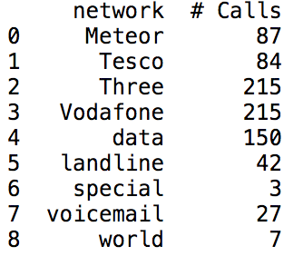

Example 5: Grouping Summaries
There are many methods for summarizing of DataFrame groups. For simplicity and to enable user-friendly column names, this example shows how to perform group summaries for individual columns before binding them together in one DataFrame. For this case, the code generates a DataFrame incrementally to shows call totals, duration means and duration maximums by network.

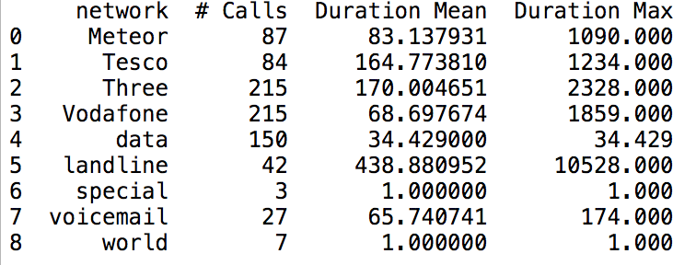
Here is the code used to create the summary DataFrame:
import pandas as pd

# The data file path and file name need to be configured.
PATH = "/Python/DataSets/"
CSV_DATA = "phone_data.csv"

# Note this has a comma separator.
df = pd.read_csv(PATH + CSV_DATA, skiprows=1, encoding = "ISO-8859-1", sep=',',
names=('index', 'date', 'duration', 'item', 'month','network',
'network_type' ))
# Get count of items per month.
dfStats = df.groupby('network')['index']\
.count().reset_index().rename(columns={'index': '# Calls'})

# Get duration mean for network groups and convert to DataFrame.
dfDurationMean = df.groupby('network')['duration']\
.mean().reset_index().rename(columns={'duration': 'Duration Mean'})

# Get duration max for network groups and convert to DataFrame.
dfDurationMax = df.groupby('network')['duration']\
.max().reset_index().rename(columns={'duration': 'Duration Max'})

# Append duration mean to stats matrix.
dfStats['Duration Mean'] = dfDurationMean['Duration Mean']

# Append duration max to stats matrix.
dfStats['Duration Max'] = dfDurationMax['Duration Max']
print(dfStats)

Exercise 5 (2 marks)
Modify the code in Example 5, so the output also includes a call duration minimum and a call duration standard deviation. Show your revised program here. (No screenshots of code please):
dfDurationMin = df.groupby('network')['duration']\
.min().reset_index().rename(columns={'duration': 'Duration Min'})
Print(dfDurationMin)
dfDurationStd = df.groupby('network')['duration']\
.std().reset_index().rename(columns={'duration': 'Duration Standar deviation'})
Print(dfDurationStd)

Exercise 6 (3 marks)
Write a program to group phone calls by network type. Show network_type, total calls, duration mean, duration max, duration minimum and standard deviation in your output.
dfStat = df.groupby(‘network type’)[‘# Calls’].count().reset_index().rename(columns={‘# Calls’:’Total Calls’})
dfDurationMean = df.groupby(‘network type’)[‘duration’].mean().reset_index().rename(columns={‘duration’:’Duration mean’})
dfDurationMax=df.groupby(‘network type’)[‘duration’].max().reset_index().rename(columns={‘duration’:’Duration max’})
dfDurationMin=df.groupby(‘network type’)[‘duration’].min().reset_index().rename(columns={‘duration’:’Duration min’})
dfDurationStd=df.groupby(‘network type’)[‘duration’].std().reset_index().rename(columns={‘duration’:’Duration Standar deviation’})

dfStat[‘Duration Mean’]=dfDurationMean[‘Duration mean’]
dfStat[‘Duration Max’]=dfDurationMax[‘Duration max’]
dfStat[‘Duration Min’]=dfDurationMin[‘Duration min’]
dfStat[‘Duration Standard deviation’]=dfDurationStd[‘Duration Standar deviation’]

Exercise 7 (4 marks)
Using the baby sample, group on either male or female and show the maximum weight, minimum weight, and mean weight. Show your program here. (No screenshots please):
df2 = df.groupby('sex')['Weight'].max().reset_index().rename(columns={'Weight':'Max Weight'})
dfMinWeight = df.groupby('sex')['Weight'].min().reset_index().rename(columns={'Weight':'Min Weight'})
dfMeanWeight = df.groupby('sex')['Weight'].mean().reset_index().rename(columns={'Weight':'Mean Weight'})
df2['Min Weight'] = dfMinWeight['Min Weight']
df2['Mean Weight'] = dfMeanWeight['Mean Weight']
final_df2 = df2[(df2['sex']=='M')]
print(final_df2)

Generating a Calculated Column
If the same calculation can be applied to each row of a column you can sometimes, do it all at once.

Example 6: Generating a Calculated Column
This example generates a Celsius column by performing a global calculation with the Fahrenheit column.
import pandas as pd

# Create data set.
dataSet = { 'Fahrenheit': [85,95,91] }

# Create dataframe with data set and named columns.
# Column names must match the dataSet properties.
df = pd.DataFrame(dataSet, columns= ['Fahrenheit'])

df['Celsius'] = (df['Fahrenheit']-32)*5/9
# Show DataFrame
print(df)
The output is shows that a Celsius column has been created and values that correspond to neighbouring Fahrenheit values have been inserted.

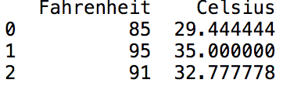

Exercise 8 (2 marks)

Starting with the result from Example 6, create a third column in the DataFrame which stores Kelvin. The formula for calculating is:

Kelvin = Celsius + 273.15

Show your program here (no screenshots please):
df[‘Kelvin’]=df[‘Celsius’]+273.15

Grouping on Multiple Columns
Grouping on multiple columns can be achieved using a comma separated list of columns:
﻿ df.groupby(['network', 'month']).count().reset_index()

Example 7: Grouping on Multiple Columns
This code implements grouping on phone network and index to show the mean duration:
﻿ import pandas as pd

# The data file path and file name need to be configured.
PATH = "/Python/DataSets/"
CSV_DATA = "phone_data.csv"

# Note this has a comma separator.
df = pd.read_csv(PATH + CSV_DATA, skiprows=1, encoding = "ISO-8859-1", sep=',',
names=('index', 'date', 'duration', 'item', 'month','network',
'network_type' ))

df2 = df.groupby(['network','item'])['duration'].mean().reset_index()
print(df2)
Here is the resulting DataFrame:
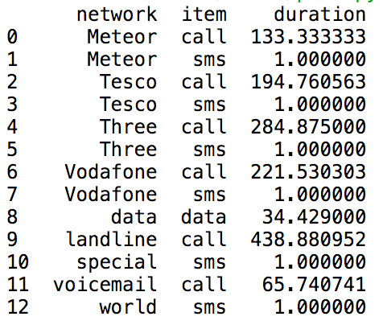
Exercise 9 (1 mark)
Modify Example 7 to enable grouping on network type and then item. Show the total count for each. Show your program here:
Df2 = df.groupby([‘network type’,’item’])[‘item’].counts().reset_index().rename(columns={‘item’:’Total count’})

Modifying one Cell of a Data Frame at a Time
Modifying cells of the data frame is a bit awkward. At least I find the syntax is inconsistent with the code used to reference a cell. You may find a better way that you like. I will show a way that works best for me.

Example 8: Updating on DataFrame Cell at a Time

This example first creates a data frame and stores Celsius data in it. Then, the code iterates through the existing data frame and changes the temperatures to Celsius.
Data frame with original data in Celsius:
City Temperature
0 Mumbai 23.0
1 Beijing -11.0
['City', 'Temperature']

Dataframe after changed to Fahrenheit:
City Temperature
0 Mumbai 73.4
1 Beijing 12.2

The line of code needed to update the cell uses the iat[] reference:
df.iat[i, tempColumnPosition] = celsius*9.0/5.0 + 32

This iat reference requires row and column indices. We can obtain a listing of the data frame columns in sequence from left to right with the following code:
columnList = list(df.keys())

Once the column list is obtained, we can iterate through the list to find the matching column:
columnPosition = 0
for i in range(0, len(columnList)):
if(columnList[i]==columnName):
columnPosition = i
break # Exit the loop.
return columnPosition

Here is the full program:
import pandas as pd

dataset={"City":['Mumbai', 'Beijing'], "Temperature":[23.0, -11.0]}
df = pd.DataFrame(dataset, columns=['City', 'Temperature'])
# Show original data frame.
print("Data frame with original data in Celsius:")
print(list(df.columns))

# return the position of a column name

def getColumnPosition(columnName):
columnList=list(df.columns)
for i in range(len(columnList)):
if columnList[i]==columnName:
return i
break

# Update cell values - one at a time.
tempColumnPosition = getColumnPosition("Temperature")

for i in range(0, len(df)):
celsius = df.iloc[i]['Temperature']

df.iat[i, tempColumnPosition] = celsius*9.0/5.0 + 32.0

print("\nDataframe after changed to Fahrenheit: ")
print(df)

Exercise 10 (6 marks)
Dynamically adjust Example 8 to change the city values, one cell at a time, so the updated data in the data frame becomes:
City Temperature
0 The city of Mumbai 73.4
1 The city of Beijing 12.2

Show your revised program code here. (No screenshots please)
#re using the function to find position for city
cityColumnPosition = getColumnPosition(“City”)
df.iat[0,cityColumnPosition]= “The city of Mumbai”
df.iat[1,cityColumnPosition]= “The city of Beijing”

Converting Strings to Numbers
When you need to convert strings to numbers you can with int() and float().

Example 9: Converting Strings to Numbers
This example demonstrates how to convert string values to a whole number and a floating-point number.
unformattedInt = '233'
wholeNumber = int(unformattedInt)
print(wholeNumber)

unformattedFloat = '12.99'
print(unformattedFloat)
floatNumber = float(unformattedFloat)

print(wholeNumber + floatNumber)
The output verifies that the conversions from strings to numbers has been successful:
﻿233
12.99
245.99

Exercise 11 (1 marks)
unformattedFloat = 233.654
wholeNumber = str(unformattedFloat)
print(wholeNumber)

newFormattedInt = int(wholeNumber)
print(newFormattedInt)

Fixing the code error above here
#option 1 - newFormattedInt = int(unformattedFloat)
#option 2 - newFormattedInt = int(float(wholeNumber)) the dot doesn’t allow me converted directly to int

